The health Information technology program
Name
Institution
Course
Date

As argued by About The ONC Health IT Certification Program | HealthIT.gov (2021) the health Information technology is a program that depends on the use of certified health information technology that has already expanded to government and non-government related programs. Throughout the review of Certification the grading criteria for the office of the national coordination, I learned and gained more insights on how the ONC health Information Criterion Certification program works. This program operates under certification criteria that have been recently released and under particular new regulations been effected following the expansion of requirements for this program. The criteria are technical and information sharing requirement, authorized surveillance body, and the requirement for Health Information Technology developers to be certified IT and embrace transparency. These requirements are instrumental in that any healthcare organization that has adopted them is assured that those who use a certified health information technology have adequate knowledge concerning both limitations and costs linked to its use or implementation based on consistency of its Certification.
I have learned that the Health Information technology stakeholders make use of the test method edition of 2015 that works as a guide in developing health information technology modules. This particular test offers a formal way of evaluating if Health IT is conforming to certification criteria. Reviewing through the electronic prescribing I realized that certification companion guide is designed with certain criteria to help in development Health information technology product since it extracts certain rules that clarify interpretation concerning Health IT product. The Guide offers certification requirements concerning both security and privacy, which is a criterion adopted to govern the testing of products presented for Certification. This criterion requires that the product should be tested only one time. The second criterion under the certification requirement concerns performance and designs. This criterion is certified for the product to be certified. This product stays safe and enhanced to support identifying a single quality management system once used.
Rxnorm has been used as a medical concept or unified medical terminology about sending and receiving specific prescriptions of certain transactions through electronic means and following NCPDP Script standard implementation. I have learned that under the health Information technology program, RxNorm is a standard code that is set such that developers can be allowed to upgrade their product effectively while complying with RxNorm's new version. This is important in avoiding interrupting the certification status of the developer's product. It is also useful to uniquely as drug identifier, although it is not all medication with its code. If there is no RxNorm in certain medicines, other codes can be used, but health Information Technology needs to make sure if there is any correspondence of these RxNorm Codes then should be to be used. Developers need to be flexible when determining how notification messages should be presented to the users. It is recommendable that they work in partnership with providers and ensure any notifications are alert messages in real-time because there is always a difference between notifications and a type of message.
I have also learned that based on technical explanation and clarification during program testing, errors linked to RxNorm are viewed as warning signs. Based on the test story on immediate cancelation of a new prescription, it is straightforward for the pharmacy to cancel any medication. In case of a precondition, the test prescribers, patients and pharmacies are pre-configured by the vendor. The verification, cancel Rx, and the system generate its related message with the help of NCPDP SCRIPT V2017071. The XML compares drug description with the RxNorm and any connected system visually and sigText to the test description direction.
Screenshot of example message
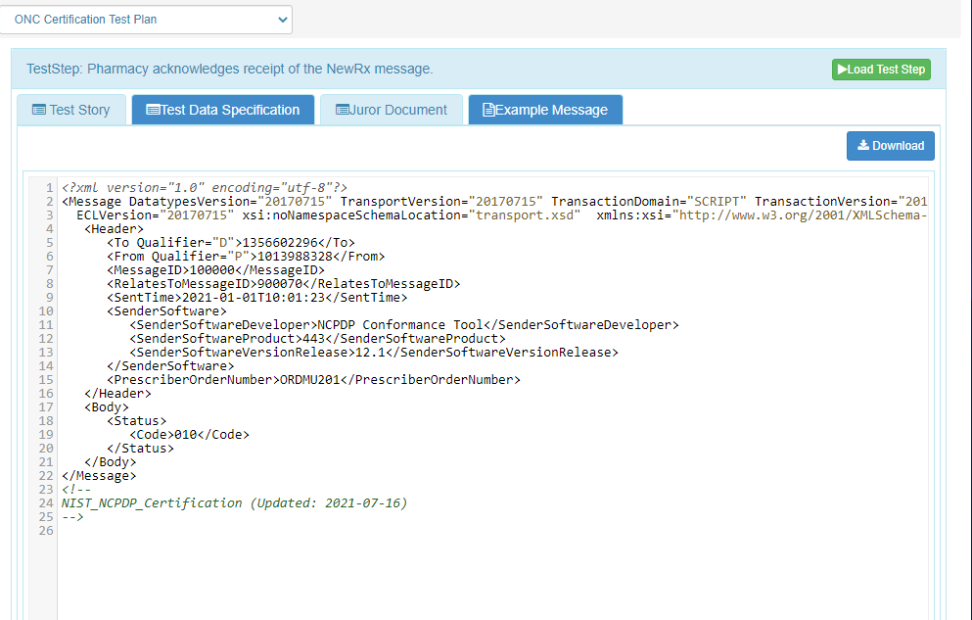

Reference
About The ONC Health IT Certification Program | HealthIT.gov. (2021). Retrieved 22 August 2021, from https://www.healthit.gov/topic/certification-ehrs/about-onc-health-it-certification-program

